1. Which solution was most effective at removing copper from the used copper chloride solution— sodium carbonate or sodium phosphate? Explain your evidence.

4. Reflection: Look back at your answer to Analysis Question 2 from Activity 23, “Producing Circuit Boards.” Now that you’ve completed the unit, has your idea of what to do with the waste changed? Explain.

2. Table 2, “Summary of Precipitation Reactions,” shows information about each of the substances you used to precipitate copper. Based on your answer to Analysis Question 1, your results from Activity 27, and the information in the table, which precipitation reaction would you recommend a company use to reclaim copper? Be sure to support your answer with evidence, and discuss the trade-offs.
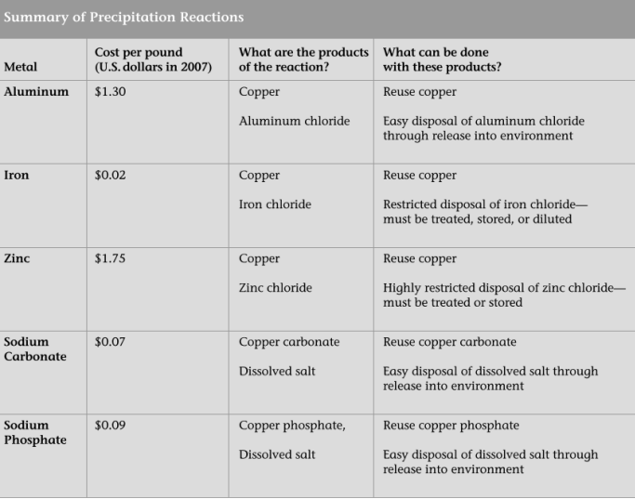

3. (ET ASSESSMENT) The Graded One!!!
- Making 1,000 circuit boards can produce more than 18,500 liters (5,000 gallons) of copper-containing wastes. How do you think this toxic waste should be handled? Review your results from Activities 24–28, and the information you have collected on Student Sheet 24.2, “Treating Waste,” and support your answer with evidence. Be sure to consider dilution, incineration, precipitation, and any other option that would reduce the environmental harm from the production of circuit boards

