If the copper metal that started out in the paper is not in the smoke, what do you think happened to it?
Challenge:

Hypothesis:

Vocabulary:
precipitation

precipitate

Filtration

Reduction
Thinking Space:
Predict what will happen if you were to add one of the washers to the used copper chloride solution.

NOTES:
- When adding sodium carbonate to the used copper chloride solution, it results ______________________________________________________________________________________________________________.
- There may be minor production of carbon dioxide gas as the slightly acidic copper chloride reacts with the ____________________________________.
- Adding sodium phosphate to the used copper chloride solution results in a _____________ _________________________________________________________________________.
- The lighter color of these copper-containing solutions compared to the used copper chloride (in Cup 3) indicates a ____________ ____________________________________.
- There is ____________ copper-colored metal precipitate that forms in the bottom of the filter with the sodium carbonate reaction in Cup A and ____________ for sodium hydrogen phosphate reaction in Cup B.

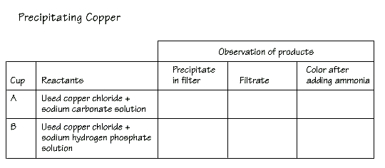
- Based on the clear to very light color of the filtrate in Cup A, one conclude that the…

- Conducting tests that determine the physical and chemical properties of the products, including:

- Do you think both types of reactions produced pure copper? Why or why not?
In Activity 27, “Reclaiming the Metal,” the precipitates were brown particles, like the copper found in pennies. In this investigation ...

Based on their physical properties, this suggests that ...

Therefore unlike the metal replacement reactions...

The reactions produced...

